Terraform Task

**Name:Shaik Khaja Basha**

**Batch : Batch 11**

**Date : 23.07.2025**

**Task : datatypes**

1. **Define all datatypes using random provider**

**Ans :**

Create a file name variable.tf using vi variable.tf and enter the details

**Primitive data types**

# 1. String Variable

variable "filename1" {

default = "abc1.txt"

type = string

}

# 2. String Variable (same as above, but explicitly typed)

variable "filename2" {

default = "abc2.txt"

type = string

}

# 3. Bool Variable – it’s a Boolean type

variable "filename3" {

default = true

type = bool

}

# 4. Number Variable

variable "filename4" {

default = 15

type = number

}

# Content can be of any type

variable "content" {

default = 10

type = any

}

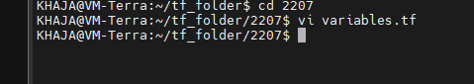

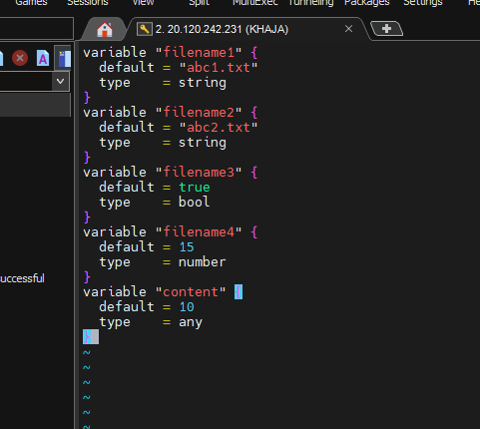

**Resources are**

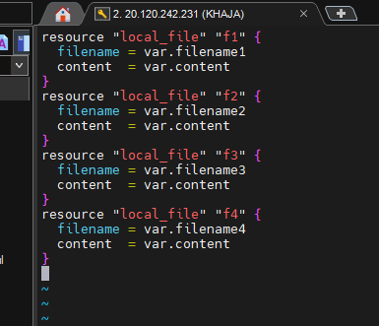

Execute the command terraform init

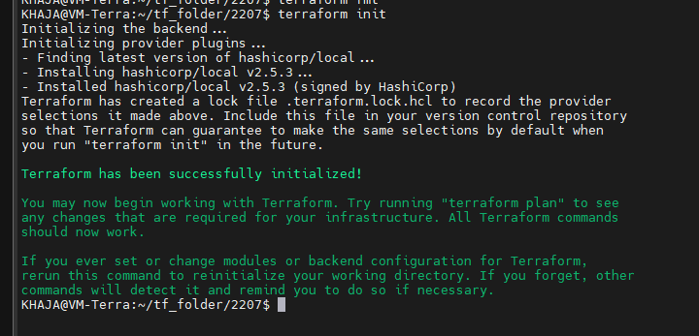

Execute terraform apply

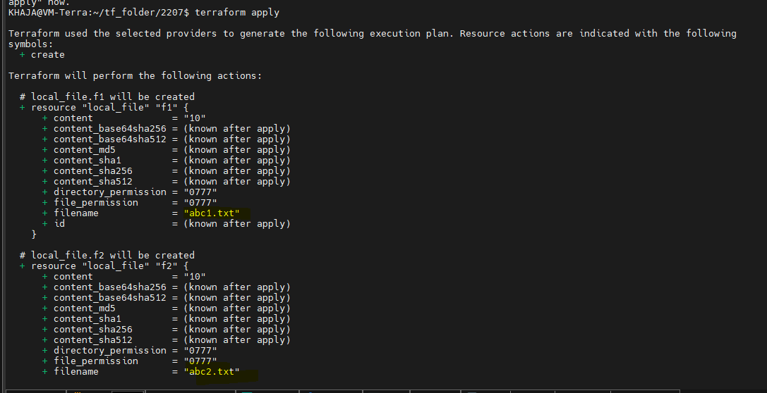

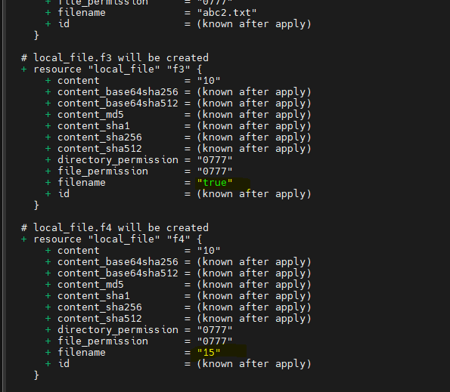

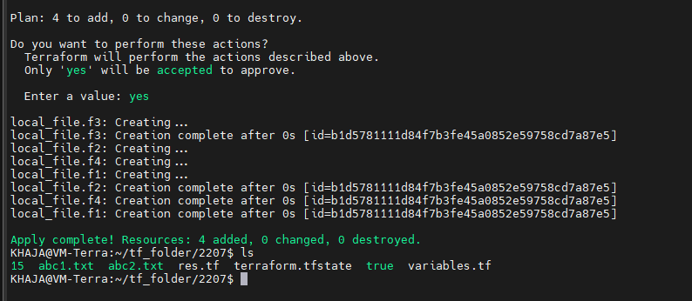

Here we can see four resources which we have given is created

**Terraform Complex / Composite / Advanced Data Types:**

**creating of resources :**

**# creating resource using set type**

resource "local_file" "f5" {

filename = var.filename5[0] # (here its using via index)

content = var.content

}

resource "local_file" "f6" {

filename = var.filename6[2]

content = var.content

}

**# creating resource using map type**

resource "local_file" "f7" {

filename = var.filename7.name # (here its using via key name)

content = var.content

}

resource "local_file" "f8" {

filename = var.filename8.id

content = var.content

}

**For Variable Declaration:**

**# list**

variable "filename5" {

type = list

default = ["test", 123, true, "test", 123]

}

variable "filename6" {

type = list(number)

default = [1,2,3,4,5, 2, 4, 7,1,2]

}

**# For Map**

variable "filename7" {

type = map(string)

default = {

name="adi"

id ="123"

isactive = "yes"

}

}

variable "filename8" {

type = map(number)

default = {

id =12345

phone =43154431

}

}

**Variable are mapped to variable file like vi variable.tf**

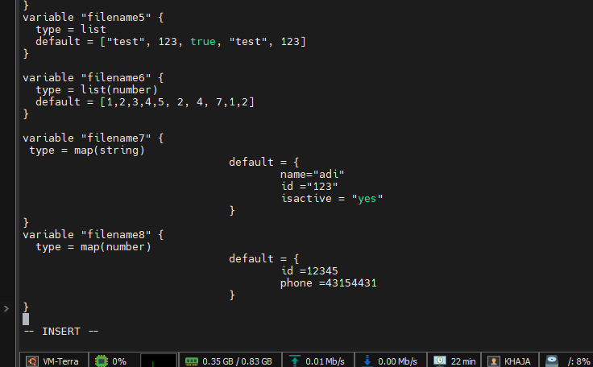

**Adding resources to the resource file “vi res.tf”**

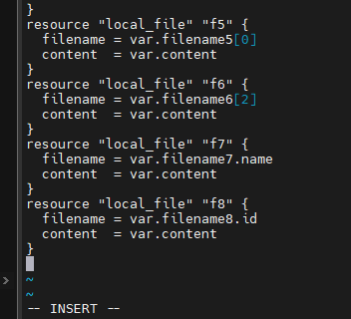

Know we have variable and resources with respect to their files

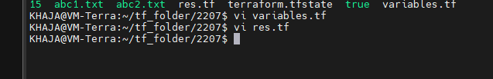

Execute the command apply

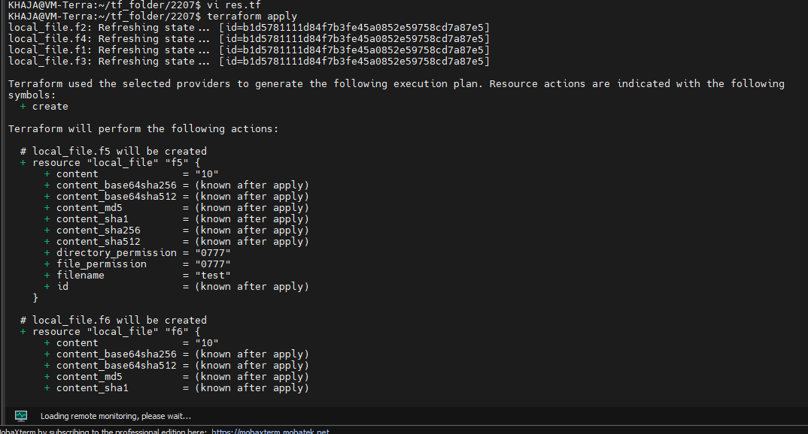

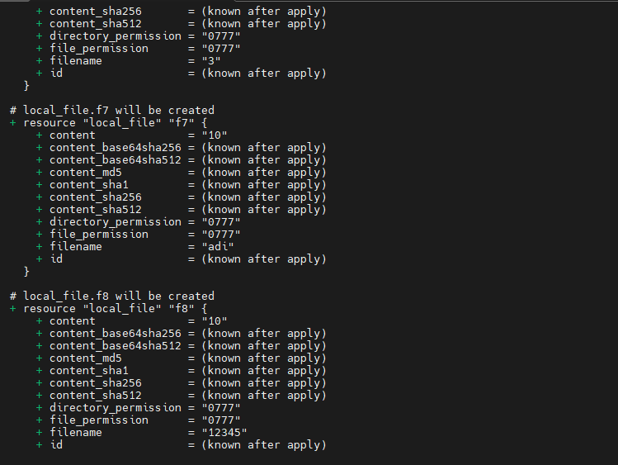

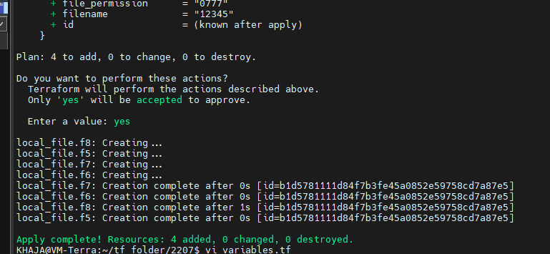

Inject the values by using .tfvar

vi terraform.tfvar

lets inject two values

filename8 = { name = "test", dob = 123 }

filename6 = [1] # we are injecting one value

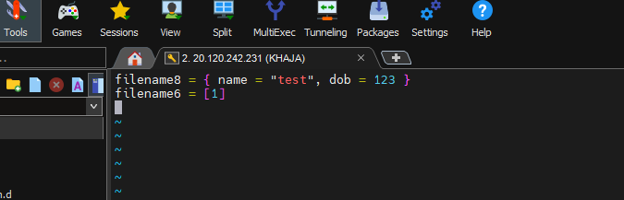

When we execute terraform apply

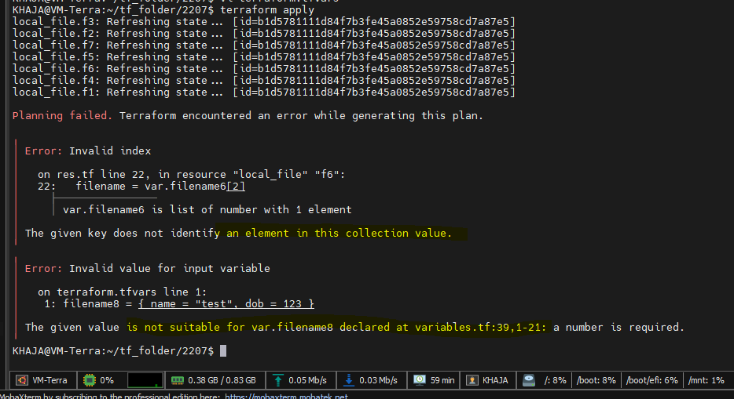

**Tuple :**

A tuple in Terraform is a fixed-length, ordered collection of values where each position has its own specific type. Unlike lists (which must contain elements of the same type), tuples can contain elements of different types.

**Tuple Characteristics:**

* Fixed number of elements (length is part of the type definition)
* Each position has a specific type
* Defined using the syntax tuple([type1, type2, ...])

Example:

variable "example_tuple" {

type = tuple([string, number, bool, list(string)])

default = ["hello", 42, true, ["a", "b", "c"]]

}

Accessing Tuple Elements:

var.example_tuple[0] *# "hello" (string)*

var.example_tuple[1] *# 42 (number)*

var.example_tuple[2] *# true (bool)*

var.example_tuple[3] *# ["a", "b", "c"] (list)*

**Random Provider**

The **Random provider** generates random values during Terraform operations. It's useful for creating unique names, passwords, or other values that need to be unpredictable.

**initialize the random provider:**

terraform {

required_providers {

random = {

source = "hashicorp/random"

version = "~> 3.0"

}

}

}

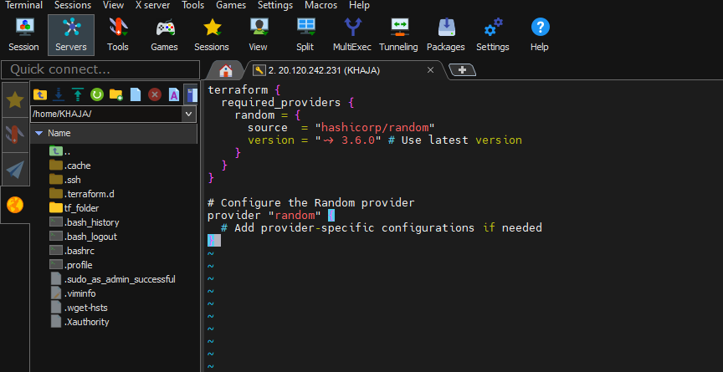

**variables.tf - Declare of variables**

variable "filename9" {

description = "A tuple containing mixed types"

type = tuple([string, number, bool, list(number)])

default = ["khaja", 1, true, [1, 2, 3]]

}

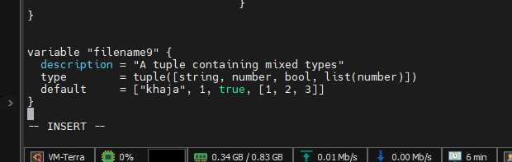

**res.tf - Define resources using Random provider**

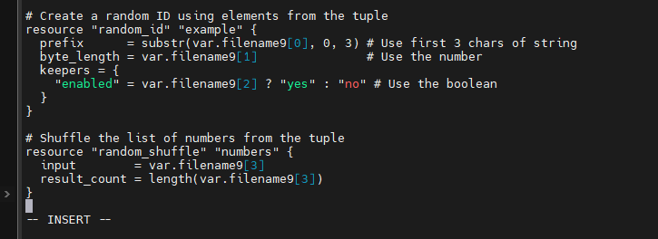

Added the resources to the existing res.tf

Execute the terraform init with update

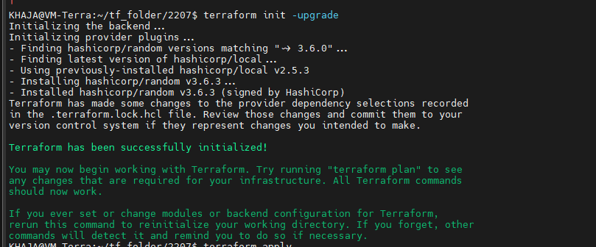

Use terraform apply to make the changes

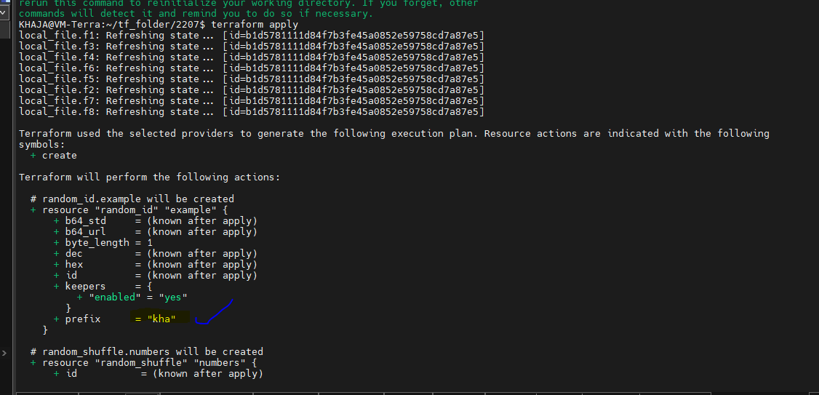

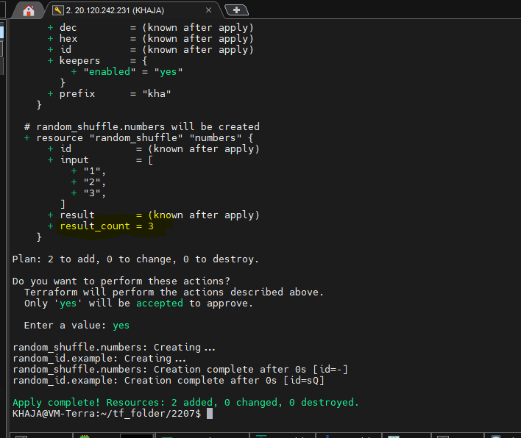

**terraform.tfvars - Provide variable values (optional)**

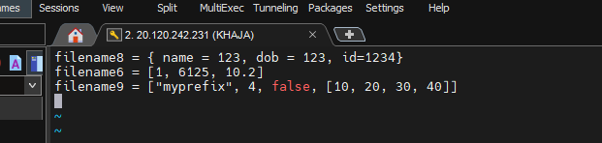

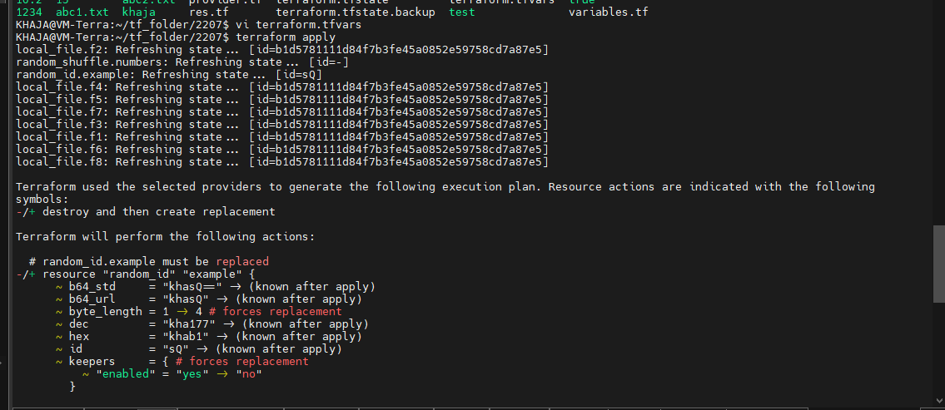

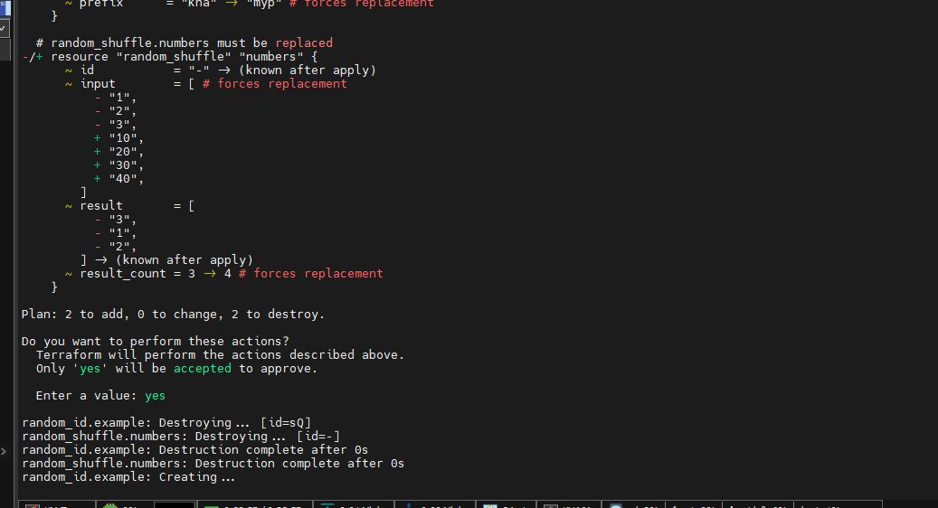

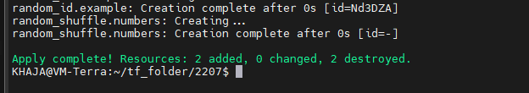

Key Benefits of This Structure:

1. **Separation of Concerns** - Each file has a clear purpose
2. **Better Maintainability** - Easier to find and modify components
3. **Reusability** - Provider configuration can be shared across modules
4. **Clear Dependencies** - Obvious where each component is defined

**object :**

user defind datatype -> wrapper on map, it declares the key structure and type

type = object({

name = string

id = number

address = list(string)

})

default = {

name = "adi"

id = 123

address = ["marathalli","bangalore","560037"]

}

**variables.tf - Object Variable Definition**

variable "filename10" {

type = object({

name = string

id = number

address = list(string)

})

default = {

name = "khaja"

id = 123

address = ["Andhra Pradesh", "Kurnool", "518001"]

}

}

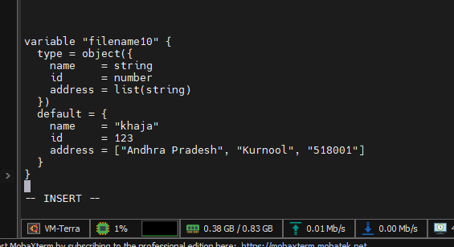

**res.tf - Random Provider Resources Using the Object**

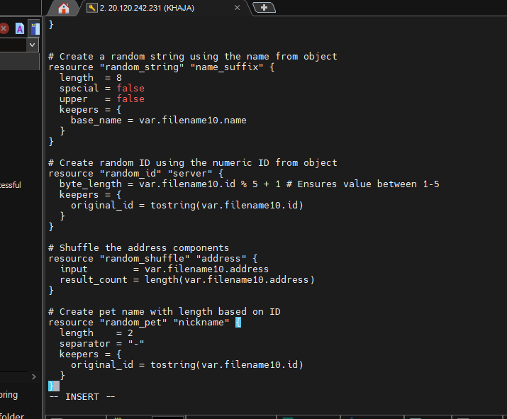

Execute the command terraform apply

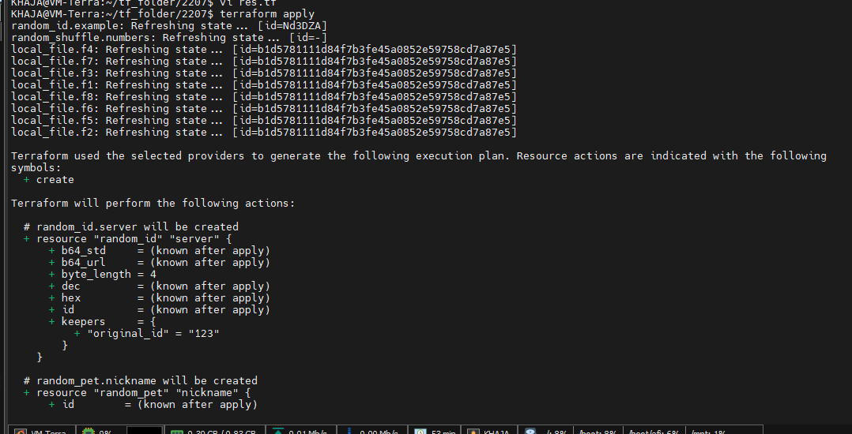

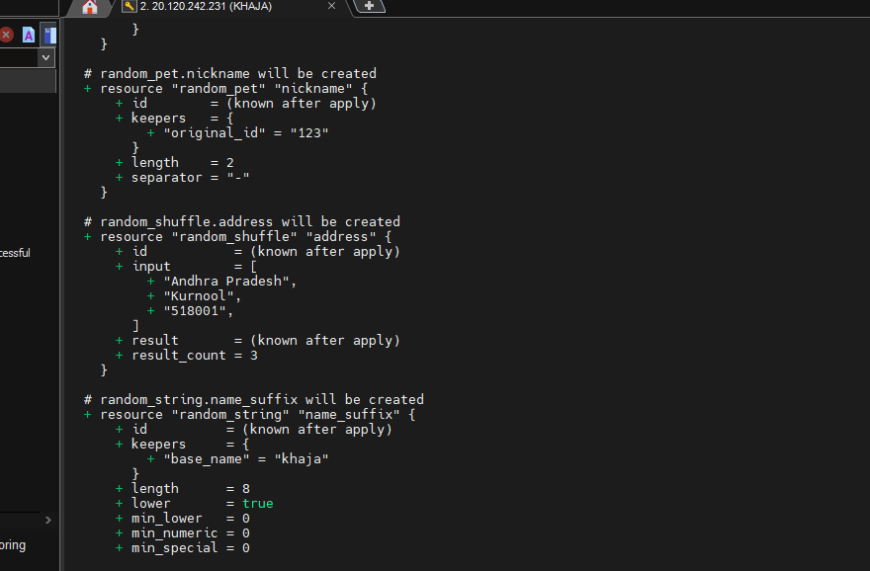

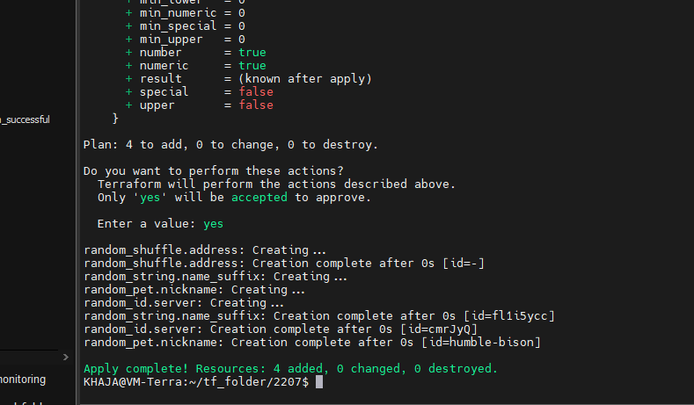

**terraform.tfvars - Provide variable values (optional)**

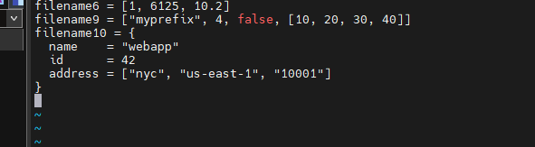

Again execute the terraform apply with the changes

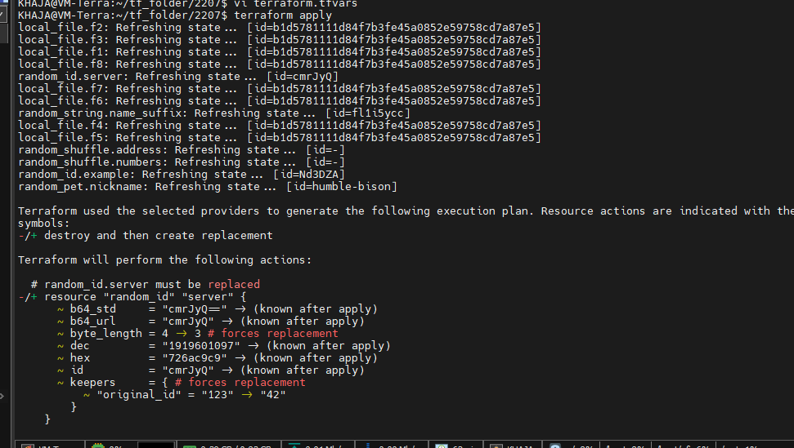

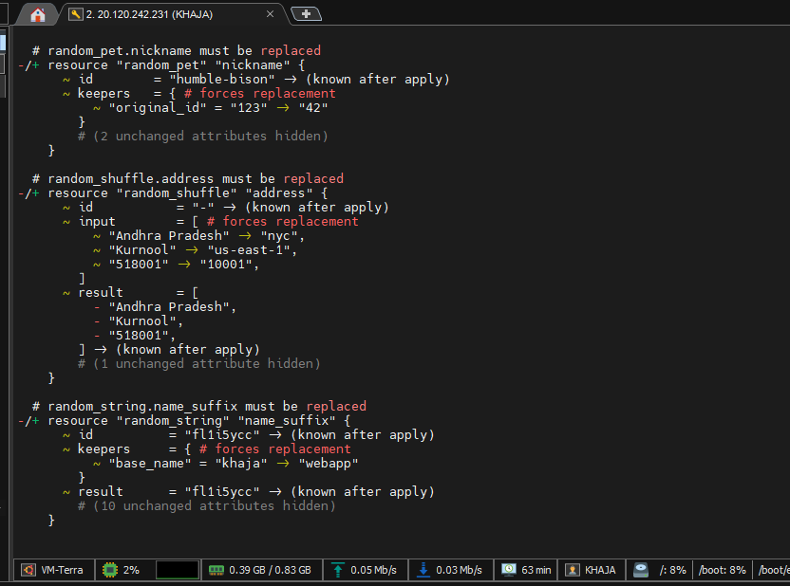

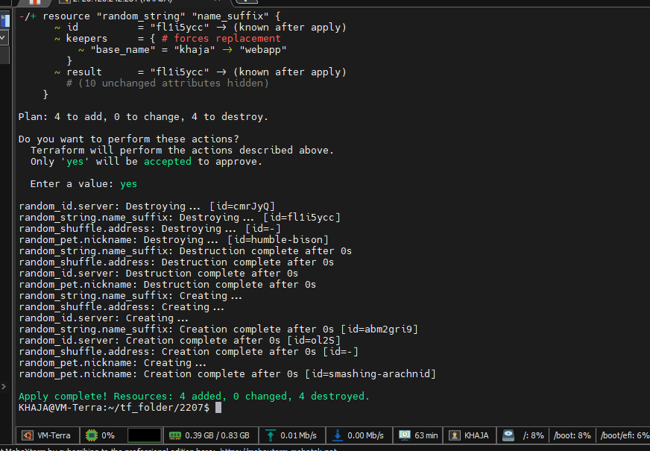

**Null provider**

A provider for creating "no-op" resources that don't provision real infrastructure.  
**Primary Use Cases:**

* Dependency management
* Debugging variables
* Triggering side effects

**Example:**

resource "null_resource" "debug" {

triggers = {

timestamp = timestamp() *# Re-runs when this changes*

}

provisioner "local-exec" {

command = "echo 'Triggered at ${self.triggers.timestamp}'"

}

}

**Using Null Provider with Tuple**

variables.tf

variable "filename11" {

type = tuple([string, number, bool, list(number)])

default = ["shaik", 1, true, [1, 2, 3]]

}

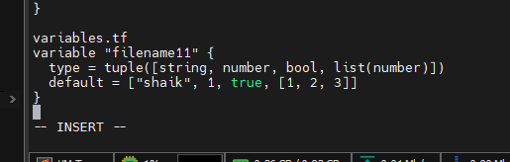

res.tf for declaring reources

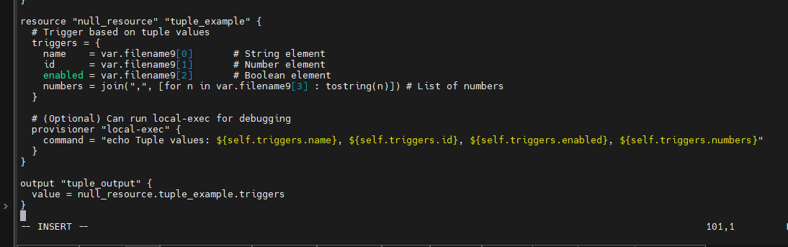

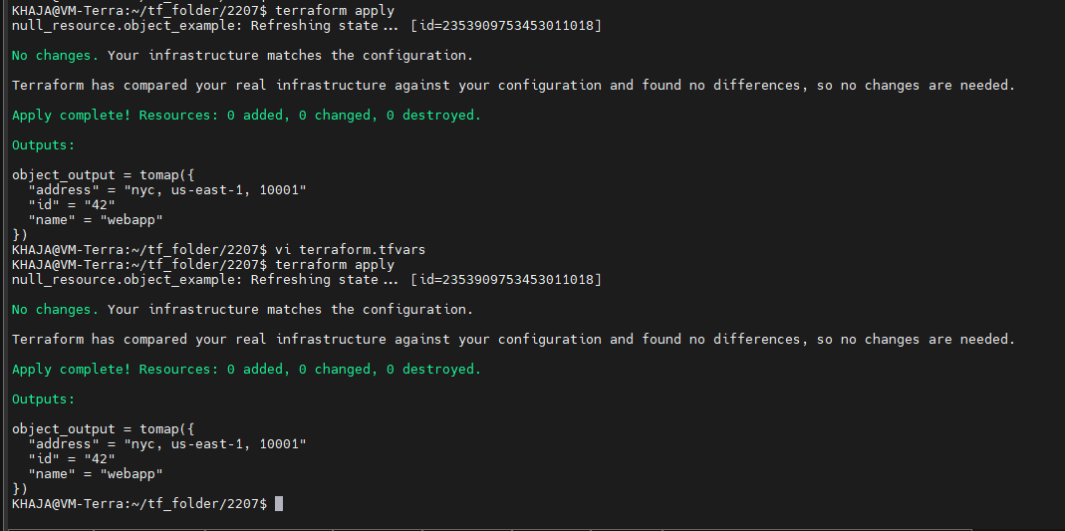

Execute the command terraform init

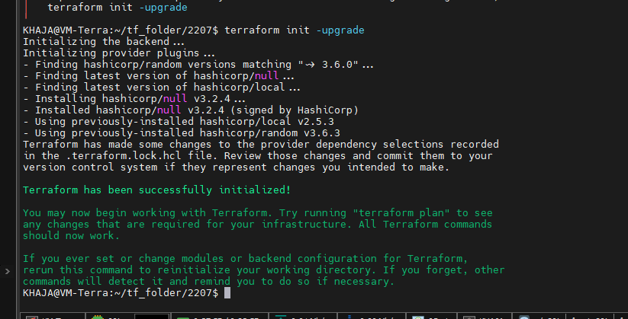

Execute the command terraform apply

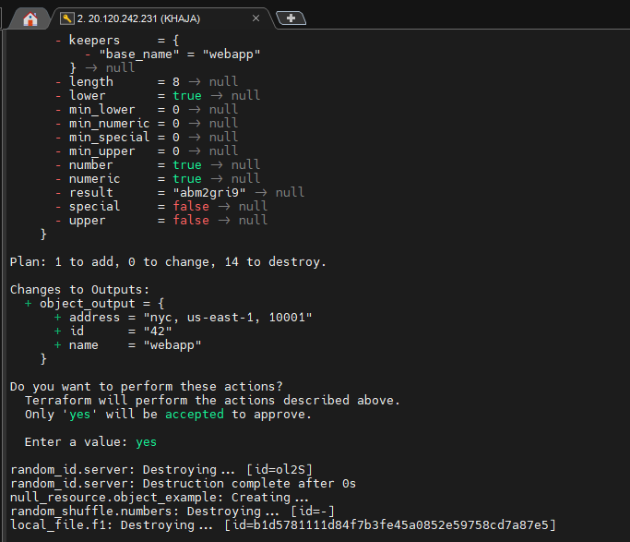

terraform.tfvars (Optional)

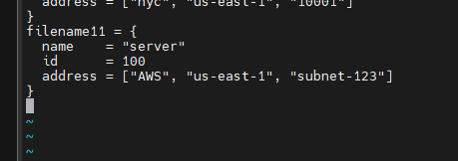

**Using Null Provider with Object**

variables.tf

variable "filename12" {

type = object({

name = string

id = number

address = list(string)

})

default = {

name = "default"

id = 0

address = ["A.P", “HYD]

}

}

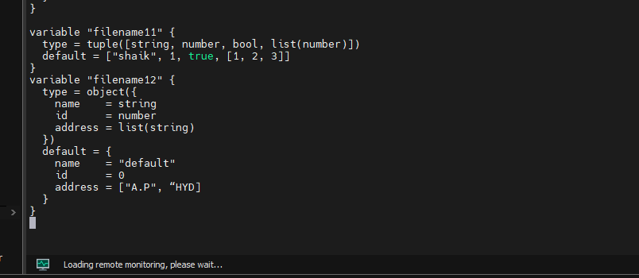

**res.tf for declaring reources**

resource "null_resource" "object_example" {

triggers = {

# Extract all object fields

name = var.filename12.name

id = var.filename12.id

address = join(", ", var.filename12.address)

}

**# (Optional) Debug output**

provisioner "local-exec" {

command = "echo Object values: ${self.triggers.name}, ${self.triggers.id}, ${self.triggers.address}"

}

}

output "object_output" {

value = null_resource.object_example.triggers

}

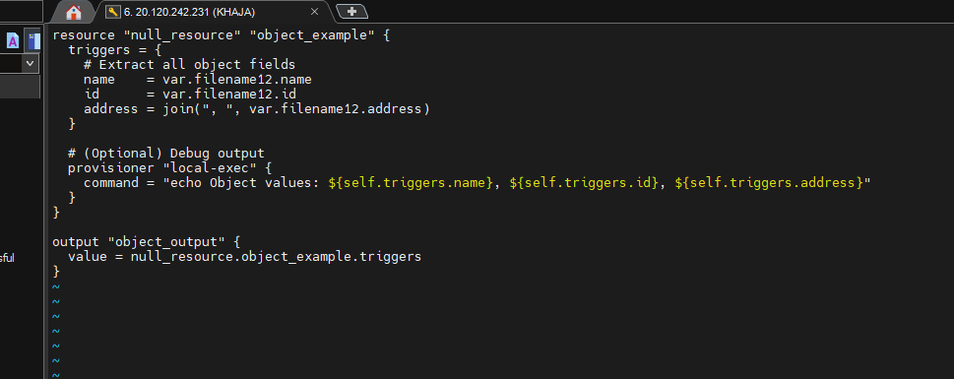

Execute the command terraform plan

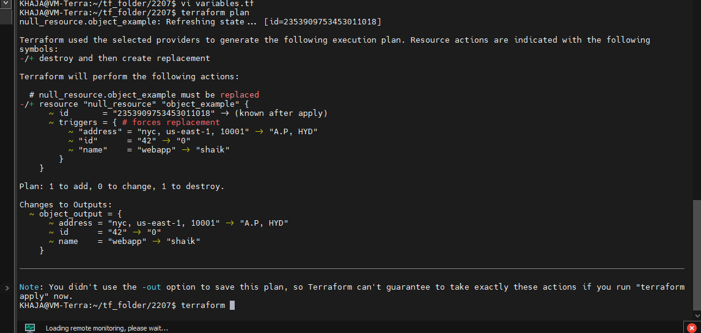

Run the command terraform apply for actual change

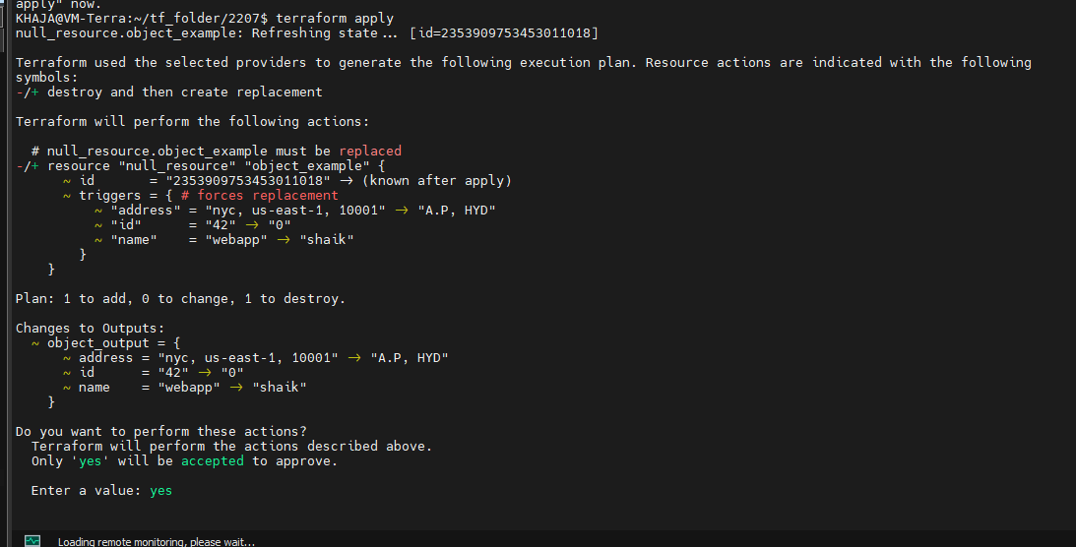

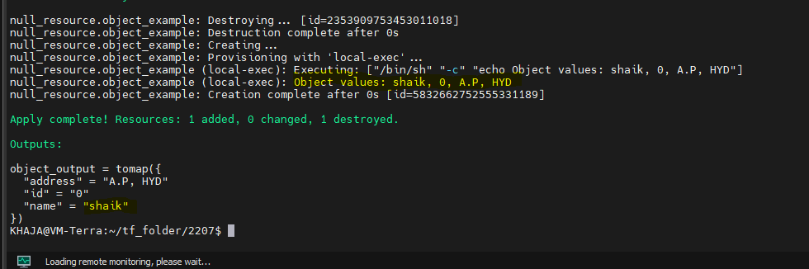

**terraform.tfvars (Optional)**

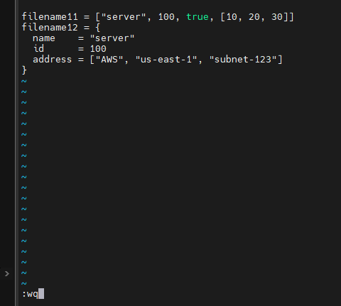

Run the command terraform apply

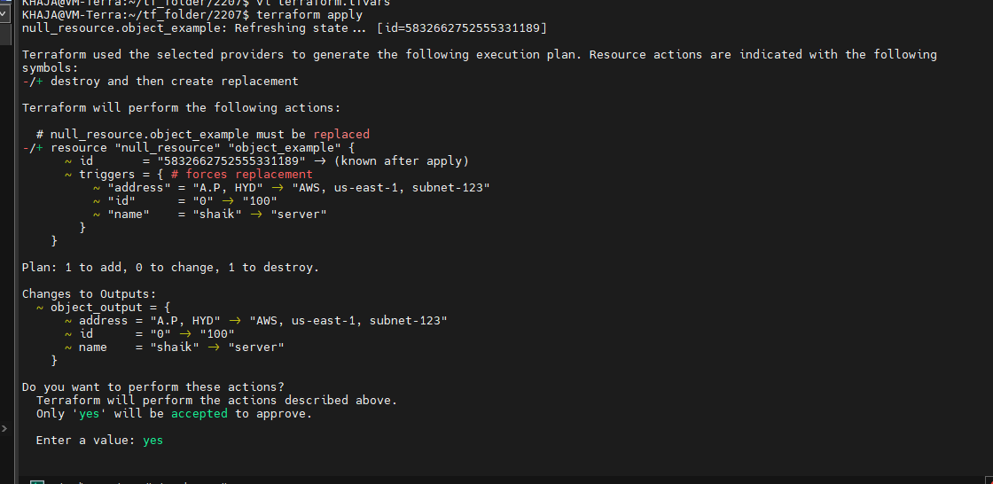

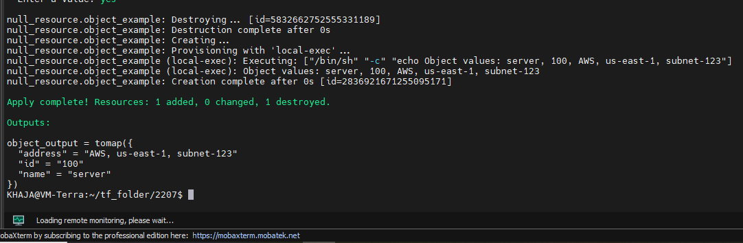

**Key Use Cases for Null Provider with Tuples & Objects**

1. **Dependency Management**
   * Ensures resources wait for variable processing before execution.
2. **Debugging Variables**
   * Use local-exec to print variable values during terraform apply.
3. **Triggering Other Actions**
   * Useful with local-exec or remote-exec provisioners when variables change.
4. **Conditional Logic**
   * Combine with count or for_each to control resource creation.